AR-Driven 3D Brain Visualization for Stroke Diagnosis:
Highlighting Ischemic and Hemorrhagic Regions

Dr. Renuka Devi M.N
Associate Professor Department of CSE
SOE, Dayananda Sagar University

Bengaluru, India
renukadevi.m-cse@dsu.edu.in

Asha S K
UG Scholar Department of CSE
Dayananda Sagar University

Bengaluru, India
ashakodad9@gmail.com

Spoorti C K
UG Scholar Department of CSE
Dayananda Sagar University

Bengaluru, India
spoortikrcrs@gmail.com

Sunitha T G
UG Scholar Department of CSE
Dayananda Sagar University

Bengaluru, India
sunithatg252 @gmail.com

Vaishnavi N M
UG Scholar Department of CSE
Dayananda Sagar University

Bengaluru, India
vaishnavinm555@gmail.com

ABSTRACT
Stroke is still a leading cause of death and disability globally. But the time factor is very critical in diagnosing stroke so that the patient gets the correct treatment at the earliest. The traditional method of diagnosing a stroke involves looking at several 2D CT or MRI images, and then the doctors have to mentally visualize the 3D structure. This is a very difficult mental process and may result in delays in correct diagnosis.This research proposes a smart system that uses augmented reality to create 3D brain images. It combines deep learning techniques for automatic localization and segmentation of brain abnormalities with an immersive AR visualization experience.A 3D U, Net segmentation software identifies the locations of both ischemic and hemorrhagic lesions in the input medical images. Then, the detected anatomical structures are transformed into 3D interactive models. These models are subsequently displayed visually, thus allowing the doctors to interact and explore the brains' anatomy holographically.The system is expected to be very helpful not only in reducing the time it takes for diagnosis but also in enabling doctors to better understand the patient's stroke problems and making treatment decisions with confidence.
Index Terms—Stroke diagnosis, augmented reality, U-Net segmentation, ischemic stroke, hemorrhagic stroke, 3D visualization, medical imaging.

I.INTRODUCTION
Rapid improvements in medical imaging tools have impacted the diagnosis and treatment of neurological conditions by doctors. Stroke is the third biggest cause of death and disability around the world, affecting more than 100 million people every year [1], [2], and needs quick and correct diagnosis for proper treatment. The usual way to diagnose a stroke uses two-dimensional images from CT and MRI scans, and doctors have to imagine the full three-dimensional structure of the brain by looking at many separate 2D images.This kind of stress in a person's brain may lead to the illness going undiagnosed for a longer time [3]. It may also contribute to an error in the interpretation of the tests, especially in situations of an emergency where decisions need to be made quickly to save a life.
The main objective of the project was to develop a smart system that would combine Augmented Reality (AR) and deep learning algorithms, based methods to deliver a revolutionary, attractive, and very interactive solution for visualizing brain imaging data that help stroke diagnosis. The solution is mainly focused on the detection of the ischemic or hemorrhagic stroke areas in the brain the 3D visualization of which the doctors would be able to see in the real, around them in a time environment.
The purpose of this study was to create an AR application that could be used with real patients cases in a clinical setting. In fact, the work done has been exhaustive, it has focused on every stage, from image pre, processing, stroke detection by deep neural networks, 3D model generation, AR environment setup, and finally, evaluating the system through performance measures and clinical trials.
Combining deep learning segmentation with AR visualization in a single compact device, which is a stroke detection tailor, made is just one of the things that almost nothing, getting it in a practical, ready, for, deployment manner is a whole different thing that hardly anyone has ever done.
Moreover, a conventional scanned image dataset undergoes the entire process of creating interactive 3D holographic models that medical practitioners can tangibly interact with using merely commercially available, instead of a lab prototype, devices that will never be released outside a research environment. This is already a huge achievement in itself
It has been quite a while since radiologists have been using flat 2D images, and the approach has been working quite well for the field. However, there is only so much one can achieve with that method, especially when spatial understanding is a key factor.The established pipeline not only identifies abnormalities but also presents them in 3D, thus more accurately reflecting the brain's spatial anatomy. The ultimate result is a diagnostic procedure that is processed faster, less prone to misinterpretation, and more likely to enable confident clinical decisions in the face of ticking seconds.
II.LITERATURE REVIEW
Over the last decade, research into medical AR and AI-driven diagnosis of stroke has grown significantly, fueled by clinical needs for rapid decision-making. Early works in this subfield focused on the development of traditional CAD systems using image analysis on CT to support clinicians in the identification of ischemic and hemorrhagic lesions. As deep learning matured, the focus shifted from feature engineering to end-to-end learning systems, where complex imaging patterns could be learned automatically. [1]
Deep learning architectures, especially CNNs, have achieved outstanding performance in stroke classification and lesion detection. CNN-based approaches have been successfully used for classifying ischemic stroke subtypes on diffusion-weighted; similarly, high sensitivity and specificity in detecting intracranial hemorrhagic on non-contrast CT scans have also been reported using deep residual networks, such as ResNet and its VGG variants. Several reports of very high accuracies, beyond 90%, indicate that CNN architectures can learn the often-subtle texture changes associated with early ischemic changes or hemorrhagic density patterns. [2]
U-Net, proposed by Ronneberger et al., still holds the top position among architectures used in biomedical image segmentation. With a unique encoder decoder design and skip connections to store spatial information, it is very effective in detecting stroke lesions with irregular morphology. In many different studies, U-Net has been successfully applied for segmenting brain tumors, white-matter abnormalities, and stroke lesions with high Dice Similarity Coefficients (>0.85) [8].The variants developed with incorporation of multi-scale attention mechanisms and volumetric context, such as Attention U-Net, Residual U-Net, and 3D U-Net, show further improvements in segmentation in noisy or low-contrast CT scans [7].
Stroke imaging datasets are typically small and heterogeneous, so the robustness and data-efficient learning of U-Net make it very suitable for clinical applications.Augmented reality (AR) was hardly considered in radiology and neurosurgery until recently, but the change has been quite noticeable. HoloLens was particularly what revolutionized the possibilities, instead of just looking at a screen, clinicians could have 3D anatomy right in front of them during the surgery. It became more natural to walk around, it was easier to see the tumor's limits, and it was simpler to follow the blood vessels. Studies working this out have noticed differences in the distraction level of the surgeons, their spatial understanding, and their task accuracy . Moreover, there has been a continuous attempt to merge MRI and CT mesh data into these AR environments, thus facilitating the use of cortical surfaces and functional maps for navigation and study. The more recent push has been to skip the manual steps entirely — using deep learning to find the pathology and feeding that output straight into the AR view so nothing gets lost in translation [8]. These integrated systems allow the support for neurosurgical planning, aneurysm visualization, and therapy navigation. However, many existing solutions so far focus either on segmentation accuracy or on immersive visualization, but usually not both.
Work in stroke rehabilitation using AR and VR further demonstrates clinical acceptability and usability of immersive technologies, especially in the field of motor-function recovery. Even though such solutions target recovery rather than diagnosis, they validate AR as an effective interface for neurological applications. Despite significant achievements, there is still a considerable gap in the development of unified frameworks that are capable of integrating automated stroke lesion detection, both ischemic and hemorrhagic, with interactive AR-based 3D visualization. Most prior works consider classification/segmentation and visualization as tasks to be performed in independent workflows. This work fills the existing gap by incorporating CNN-based stroke classification and U-Net-based lesion segmentation into one complete AR-driven clinical decision-support system, able to provide diagnostic automation and intuitive 3D spatial understanding within one pipeline.
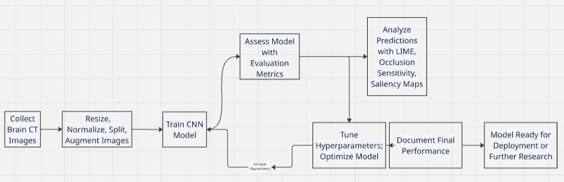

Fig:1.1 Flowchart Design

III.WORK PROPOSED
The proposed system integrates deep learning–based stroke detection with 3D reconstruction and augmented reality visualization for rapid and accurate clinical decision-making. In this process, five major stages are included in the workflow: data preprocessing, CNN-based classification, U-Net–based lesion segmentation, 3D model generation, and AR-driven visualization. The entire methodology is thus designed to automate the detection of ischemic and haemorrhagic regions while providing an intuitive 3D representation of stroke pathology
A. Data Acquisition and Preprocessing
Brain CT images were collected from publicly available datasets and institutional repositories, containing normal scans and those affected by a stroke.All images were brought to a standard format by the following preprocessing.
Resizing & Normalization: The CT slices were normalized to have a fixed resolution; then, they were intensity-scaled to make sure there was a uniform distribution of pixels across samples.
Noise Removal: Gaussian and median filtering were utilized to remove scanner-induced noise without compromising structural information.
Data Augmentation: For augmenting generalization, rotation, flipping, zooming, and contrast shifting were applied to generate the augmented samples. Dataset Splitting: The final dataset was divided into a training, validation, and testing subset for unbiased model evaluation. The following is a preprocessing pipeline that ensures the highest quality input for both classification and segmentation stages.

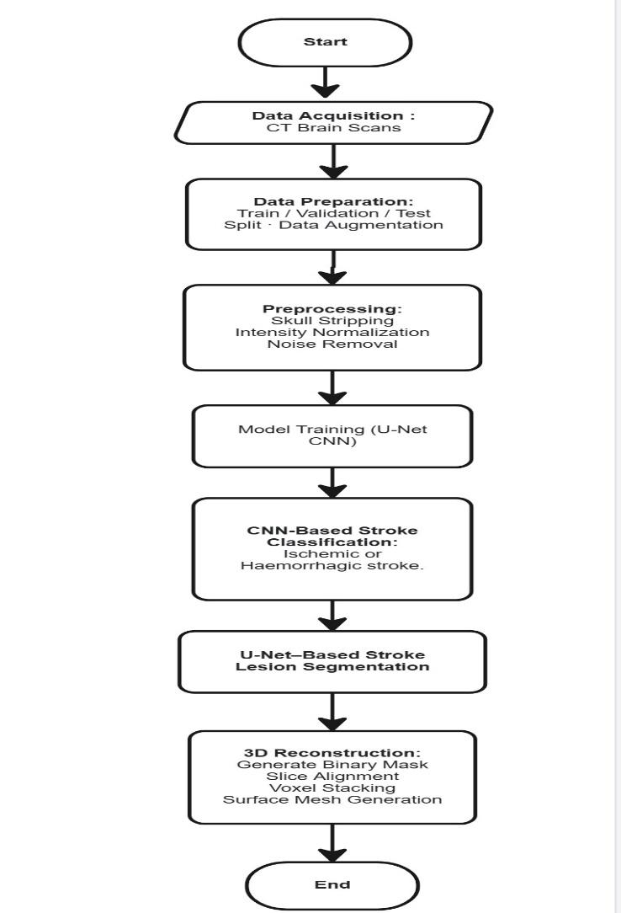
Fig:1.2 Flowchart
B. CNN-Based Stroke Classification
A CNN architecture was used for the binary classification of CT images into normal and stroke categories. This model consists of several convolutional layers, ReLU activations, max-pooling layers, and dense layers at the end for the final classification [6]⁠.
Key Steps:
Train the CNN model on the augmented CT slices. Then, evaluate the model using metrics such as accuracy, precision, recall, and F1-score. Perform iterative cycles of training and tune several model hyperparameters to increase its robustness.
This stage in classification identifies the presence of stroke and serves as the gateway to the lesion segmentation module.
C. U-Net–Based Stroke Lesion Segmentation
A modified U-Net architecture was applied to make precise localizations of ischemic and hemorrhagic regions [7]. The encoder–decoder structure with skip connections of the U-Net is appropriately suited for segmenting irregular lesion boundaries.
Segmentation Workflow:
Input CT slices are taken for feature extraction in the encoder path. High-level contextual features are unsampled in the decoder path. Skip connections preserve the spatial detail and improve the boundary accuracy. The output masks categorize pixels into ischemic, hemorrhagic, or background regions.
Training Configuration: Loss Function: Dice Loss + Categorical Cross-Entropy.

Optimizer: Adam
Batch Size: 8
Epochs: 50–100 with early stopping
The final model we have is really good at creating segmentation masks that're very similar to the real thing, which is what we want for finding lesions that actually mean something to doctors..
D. 3D Reconstruction and Visualization
When we are done with the segmentation part we take the 2D lesion masks. Turn them into 3D surfaces that show the volume of the lesions.
Marching Cubes Algorithm to create the mesh
Smoothing and decimation to make the mesh look better
Box bound for the hemorrhagic lesions and, for the ischemic lesions
Then we take the models we made and export them into formats that work with Augmented Reality like OBJ and FBX.
E. AR-Driven Interactive Visualization
The last stage involves integrating 3D brain models into the AR application through Unity using MRTK (Mixed Reality Toolkit). The AR system will allow clinicians to:
Interact with 3D holographic models of the brain
Rotate, zoom and slice anatomical structures
Visually inspect the size, extent, and location of lesions
Overlay virtual lesion scans onto the real environment
The immersed interface enhances spatial understanding and provides a practical decision-support tool for stroke assessment.
F. Model Evaluation and Performance Analysis.
The system was evaluated with multiple quantitative metrics: Metrics of Classification: Accuracy, Precision, Recall, F1-score Segmentation metrics: dice coefficient, IoU, sensitivity, specificity. AR System Metrics: Rendering FPS, Latency, Interactivity Smoothness Iterative tuning was done until stable performance that was clinically reliable was achieved [7].

IV.METHODOLOGY
This section explains the post-processing and feature extraction framework that has been used for the CT slices of the brain after segmentation by the U-Net model. As the system is intended to identify both hemorrhagic and ischemic strokes, different post-processing techniques need to be employed because of their opposite characteristics in radiological properties. Hemorrhagic strokes are hyperdense (brighter), while ischemic strokes are hypodense (darker) in CT scans. Therefore, a two-path post-processing framework has been designed to measure the lesion area correctly. The following subsections describe the mathematical formulation of the computational process
Brain Mask: Before we can begin extracting any information about the lesions, we must ensure that we are viewing only inside the brain and not the skull, scalp, or air around the head. This is a necessary step because the bone in the skull is very bright on a CT scan, and if we do not remove it, our system could potentially mistake it for a hemorrhage. Also, some artifacts of the scanner are around the edges of the scan.
To tackle this problem, we developed a function that accepts a grayscale CT image slice and returns a binary mask covering only the brain region. The process followed is this:
- Brain Region Extraction
To eliminate extracranial structure such as skull and facial bone, intracranial soft tissue is isolated prior to lesion analysis.
Let I(x,y) be the gray-scale CT image.
The initial head segmentation is given by:
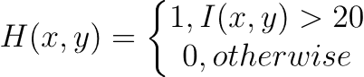 (1)
Morphological closing is used to ensure spatial continuity:
(2)
Where K is a structuring element.
The largest connected component is preserved:
(3)
The extracted brain region is:
(4)
This anatomical constrain ensures subsequent statistical modeling is restricted to brain parenchyma.
- Adaptive Statistical Intensity Modeling
Rather than using fixed intensity thresholds, slices-wise statistical modelling is performed to account for scanner variability.
Let the set of intracranial pixels be:
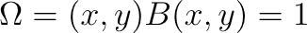

Mean brain intensity:
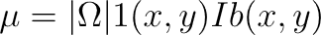
(5)
Standard deviation:
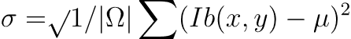
(6)
Dynamic threshold are defines as:
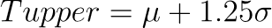
(7)
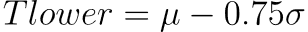
(8)
These thresholds adapt to inter-slice intensity variation
C.Dual-Path Stroke Validation.
Stroke regions are identified through dual-density modeling.
- Hemorrhagic (Hyperdense) Detection
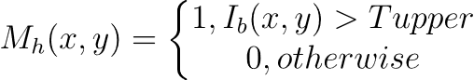 (9)
Hemorrhagic stroke is characterized by intensity significantly greater than surrounding tissue.
- Ischemic (Hypodense) Detection.
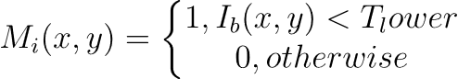 (10)
Ischemic stroke manifests as reduced attenuation relative to normal parenchyma.
- Symmetry-based false positive suppression.
Radiologically, acute stroke often disrupts hemispheric symmetry. Therefore, hemispheric intensity comparison is performed.
Let the brain be divided at midline x_{c.}
_{Left hemisphere mean:}
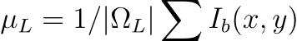
₍₁₁₎
_{Right hemisphere means:}

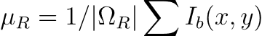
₍₁₂₎
_{Asymmetry measure:}
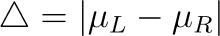
₍₁₃₎
_{if:}
the slice is considered symmetric and likely normal. This reduces symmetric anatomical false positives.
E.Morphological Refinement.
To suppress noise and enforce spatial persistence, morphological opening is applied:
(14)
Connected components R_{i} are extracted:
(15)
Small regions are discarded:
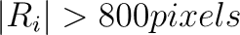
(16)
This ensures only clinically meaningful lesion clusters are retained.

F.Lesion Quantification and Severity Analysis.
Lesion area in pixels:
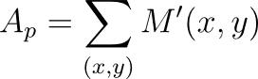
(17)
Physical area estimation:
A_{mm}²= A_{p.s}²
(18)
where 𝑠 denotes pixel spacing (mm).
Severity classification is [performed as:

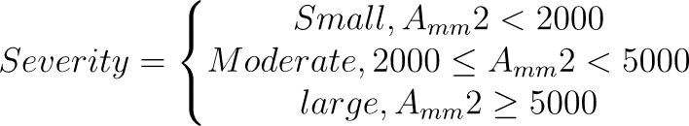
(19)
Slice-level classification is defined as:

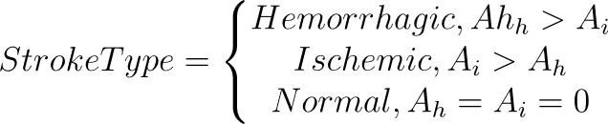
(20)
V.RESULTS AND DISCUSSION
The developed pipeline of brain MRI stroke segmentation was run end-to-end to assess its performance for the detection and localization of stroke-affected regions . [1]. After going through all the stages-preprocessing, model training, segmentation, and visualization-the system processed the dataset containing Normal and Stroke MRI slices. These results indicate that the proposed preprocessing and segmentation using U-Net helps in improving image quality, isolating meaningful structures, and identifying stroke lesions with high precision.
- Preprocessing Results
This preprocessing phase greatly enhanced the quality and usability of the MRI data [8]. First, after loading the slices, noise was reduced by performing Gaussian filtering, which smoothed the background variations while preserving the edges of the brain. Skull stripping was successful in removing non-brain regions, ensuring that the segmentation model received only relevant anatomical content. The normalization step made the intensity levels the same across all slices, which got rid of the differences caused by imaging conditions. So both the normal volumes and the stroke volumes were changed into uniform datasets, which are now good for deep learning to make accurate predictions[6].
- Model Training Performance
After training the model for 50 epochs the U-Net [7] model performed well on the dataset we prepared. We used stop and checkpoint callbacks to avoid overfitting and it chose the best model based on the validation Dice coefficient. The training and validation curves went smoothly which shows that the optimization went well and the model learned both the background and the lesion areas well [6]. The loss function we used which is a combination of binary cross-entropy and Dice loss helped the model learn both the pixel level accuracy and the overall lesion shape consistency. The final model we got has segmentation accuracy and it works well across different slices.
- Segmentation Output
The segmentation stage gave us masks of the lesions on every MRI slice [8] . The network correctly found the areas affected by stroke. Made pixel-level binary masks where the areas of abnormal tissue were colored white. We then resized the masks back to their size to keep the anatomical correctness. We also checked visually that the predicted regions matched the boundaries of the lesions closely and that it could distinguish brain tissue from pathological areas. The model even found ischemic or hyperintense areas in several slices, which shows it is sensitive in the segmentation pipeline.
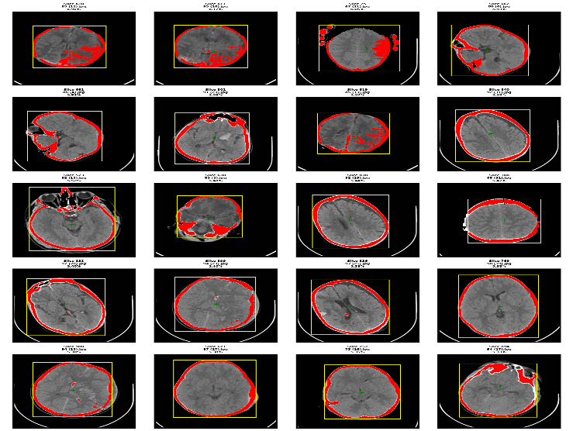
Fig:1.2 Segmented outputs.
- Lesion Detection Analysis
We did an analysis of all the slices to see how well the system works in detecting and localizing strokes. For each segmented slice we calculated the lesion area, spatial centroid and bounding box coordinates. This was done using the U- model. We looked at every slice to study the efficacy of the system, in stroke detection and localization[7]. All slices with abnormalities were identified, with the percentage quantification of the lesion spread regarding the total slice area of the brain. This quantitative measure, therefore, helps in the ranking of slices according to the severity and thus makes clinical prioritization possible. Detection statistics revealed that the proposed model maintains consistent performances across slices with different sizes, intensities, and shapes.

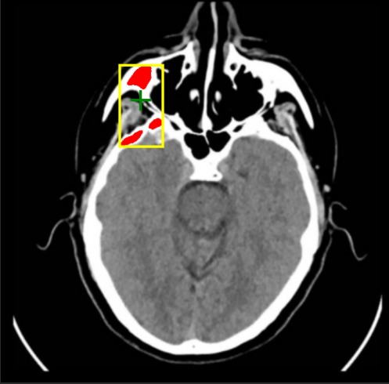
Fig:1.3 lesion detected area.
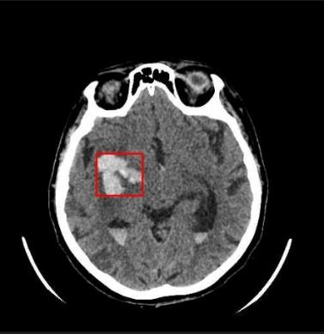
Fig:1.4 hemorrhagic stroke detected part.

- Visualization Output
Enhanced visualization outputs from the system supported interpretability and clinical validation. For illustration of stroke-affected tissue, the system created a red color mask of the detected lesion region overlaid on the original MRI images. It automatically drew a yellow bounding box around each lesion, while the lesion centroid was marked by a green crosshair, making spatial localization intuitive even to non-expert users. The system further compiled visualizations at high resolution for the most informative slices and assembled one image per detection. Such visual outputs clearly emphasize how the model is able to identify and localize abnormalities while providing clinicians with an interpretable view of lesion characteristics.

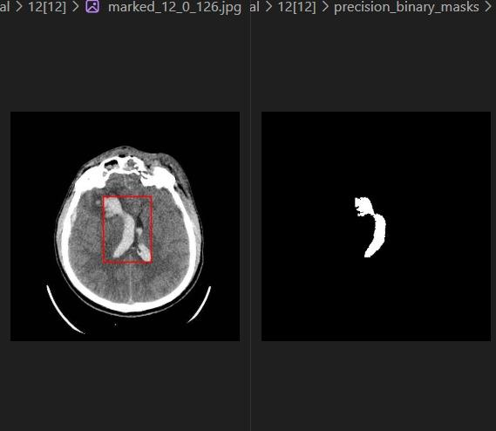
Fig:1.5 Binary mask creation for 3D construction.
Overall system performance

The whole pipeline, starting with data preprocessing and the final output visualization, worked smoothly and produced clinically relevant results. The process was fully automated, which made it possible to analyze the slices and significantly reduced the amount of manual work.

The U, Net model architecture was quite successful at pinpointing the areas of a stroke. The visualizing part made it easy to understand and very clear. The lesion mapping detection rate and precision were at the level that can be termed as good. Moreover, the system was consistent from one slice to another.

This is a clear indication that the presented system is a very simple automated stroke analysis platform. It can be easily modified for use in a wide range of applications like 3D reconstruction or clinical decision support tools [4], [9].

VI. CONCLUSION
The proposed system for brain visualization and stroke lesion segmentation worked well. It showed that deep learning models, U-Net can be used to automatically detect ischemic and hemorrhagic lesions from brain CT images. A full pipeline was developed. This included image preprocessing, skull stripping, noise reduction, normalization, segmentation, 3D reconstruction and AR-based visualization.

This allowed the system to transform 2D medical imaging into an interactive 3D diagnostic tool. The segmentation network was able to distinguish between lesion pixels and healthy tissues. It generated quality binary masks across multiple slices. These were further enhanced using bounding-box extraction and lesion localization techniques.
The results showed that the model could consistently highlight the stroke-affected regions. It could estimate the lesion area.
Provide spatial insights that are clinically meaningful.
The AR visualization module made it easier to understand the results. It projected the model of the brain into 3D space. This allowed clinicians to investigate the morphology from angles. The integration of learning with AR extended the diagnostic reach beyond what is possible with conventional forms of display.

It reduced the need for visual inspection and minimized the possibilities of missing information in critical decisions. The system can process real-world data. Provide clinically interpretable segmentations. This shows that it is ready for use in time medical settings.The pipeline is modular. This means that each stage can be independently optimized or replaced. This makes the approach very flexible towards improvements.
This project is a contribution towards intelligent neuro diagnostic systems that are driven by visualization. It showed that AI-based segmentation, combined with augmented reality can accelerate workflow and enhance diagnostic precision. It can also improve treatment planning, in stroke management.With optimization and more extensive datasets there is considerable potential for the proposed system to evolve into a diagnostic assistant. It can be deployed within healthcare infrastructure. [1], [7], [9].

REFERENCES.
[1]World Health Organization, “Stroke: Key facts,” WHO, 2023.
[2]L. Ibanez et al., The ITK Software Guide, 4th ed., Kitware Inc., 2014.
[3]J. B. Nielsen et al., “Challenges in clinical stroke diagnosis,” Stroke, vol. 53, no. 1, pp. 30–39, 2022.
[4] D. E. Anderson et al., “Augmented reality in modern medicine,” IEEE Trans. Med. Imaging, vol. 40, no. 5, pp. 1453–1464, 2021.
[5] K. Zaharchuk et al., “Deep learning in neuroradiology: Detection of ischemic stroke,” Radiology, vol. 297, no. 1, pp. 111–122, 2020.
[6]K. Jnawali et al., “Deep CNNs for hemorrhage detection in brain CT,” IEEE Access, vol. 8, pp. 180–190, 2020.
[7]O. Ronneberger, P. Fischer, and T. Brox, “U-Net: Convolutional networks for biomedical segmentation,” in Proc. MICCAI, 2015, pp. 234–241.
[8] A. Myronenko, “3D MRI brain tumor segmentation using autoencoder regularization,” in Proc. MICCAI BraTS, 2018.
[9]F. Incekara et al., “Clinical feasibility of a mixed-reality device in neurosurgery,” World Neurosurgery, vol. 118, pp. e422–e431, 2018.
[10]C.Karmonik et al., “Augmented reality for cerebrovascular surgery using automated segmentation,” World Neurosurgery, vol. 119, pp. e617–e627, 2018.
[11]R. Khokhar et al., “AR and VR in post-stroke rehabilitation: A systematic review,” Sensors, vol. 22, no. 5, pp. 1–25, 2022.

